OS Assignment – 2

Name: Sayali Prabhudas Wagh Div-D Roll-67

1. Select any 5 capitals of states in India and enter them in a file named capitals1. Choose 5 more capitals and enter them in a file named capitals2. Choose 5 more capitals and enter them in a file named capitals3. Concatenate all 3 files and redirect the output to a file named capitals.

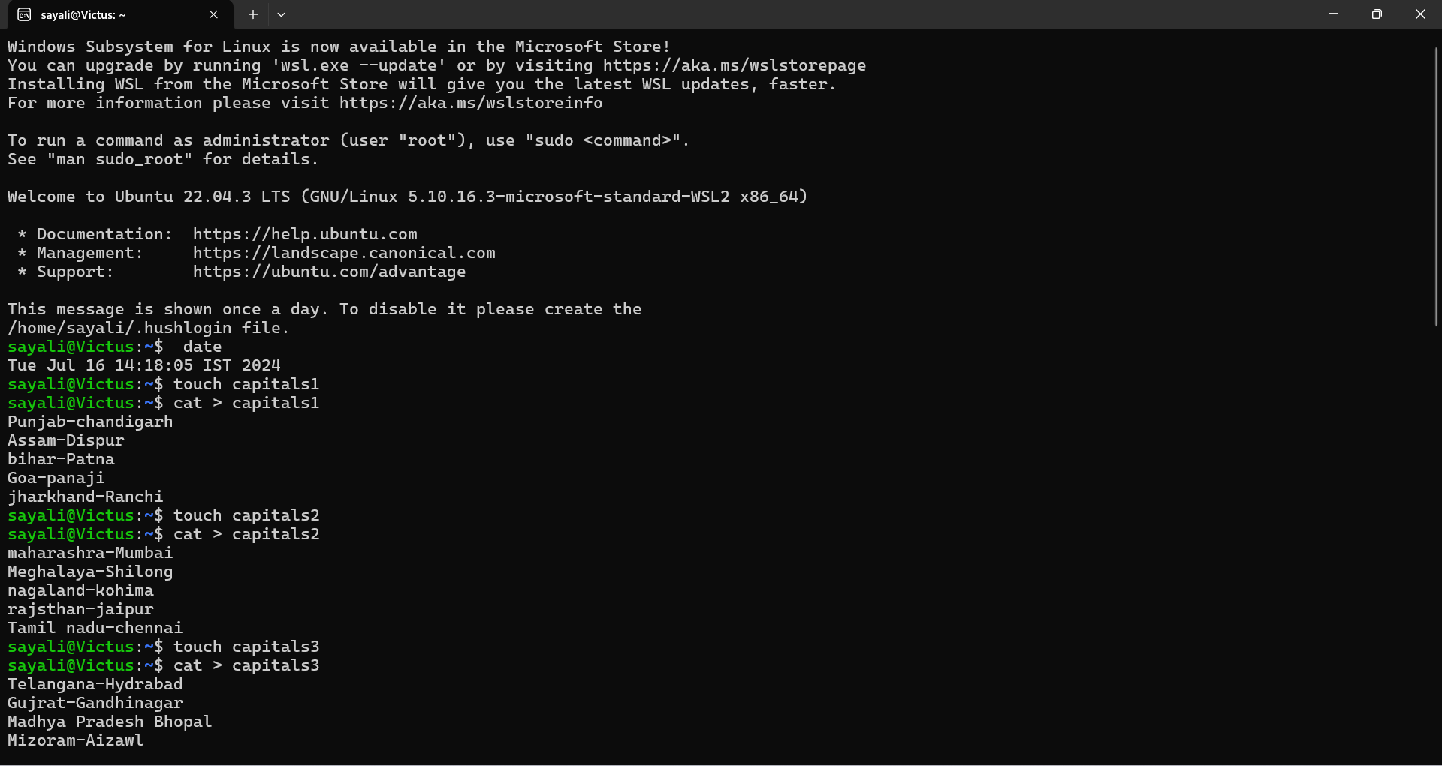

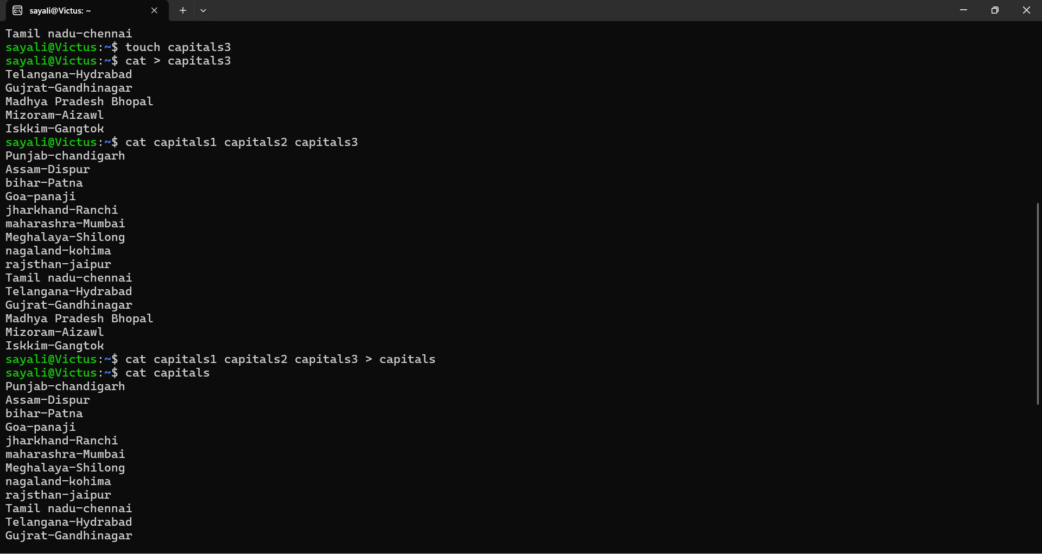

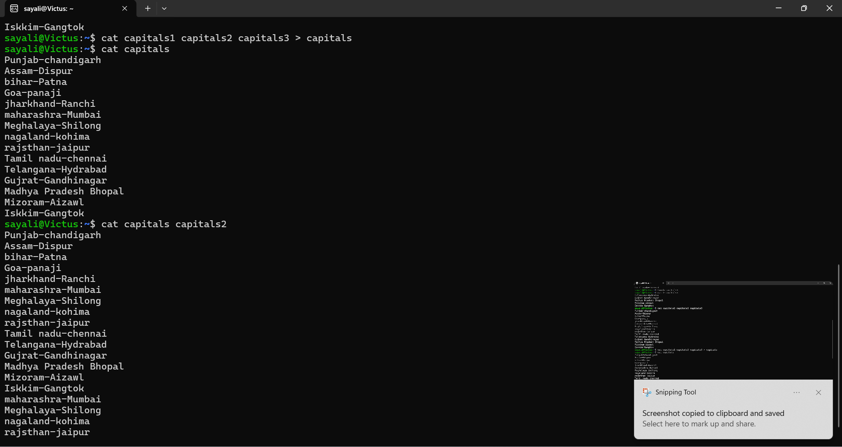

1. Concatenate the file capitals2 at the end of file capitals.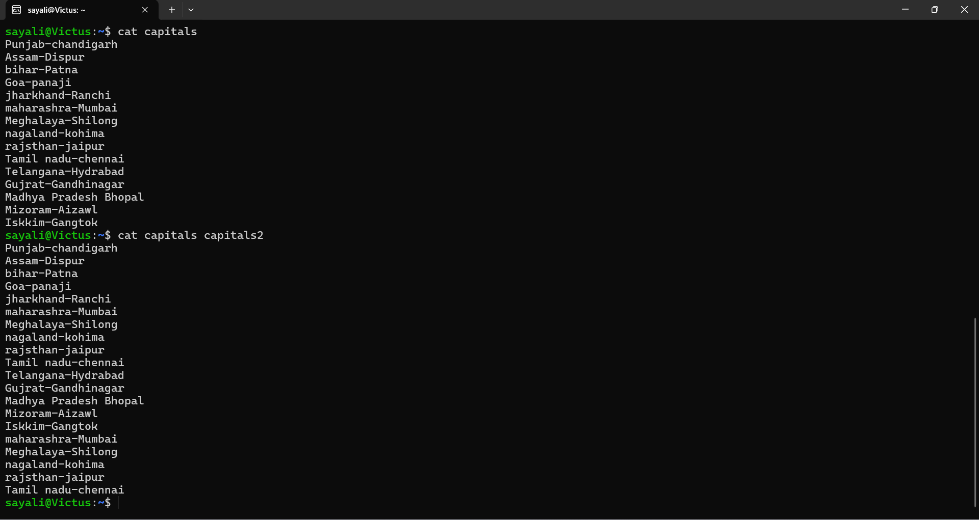
2. Redirect the file capitals as an input to the command “wc –l”.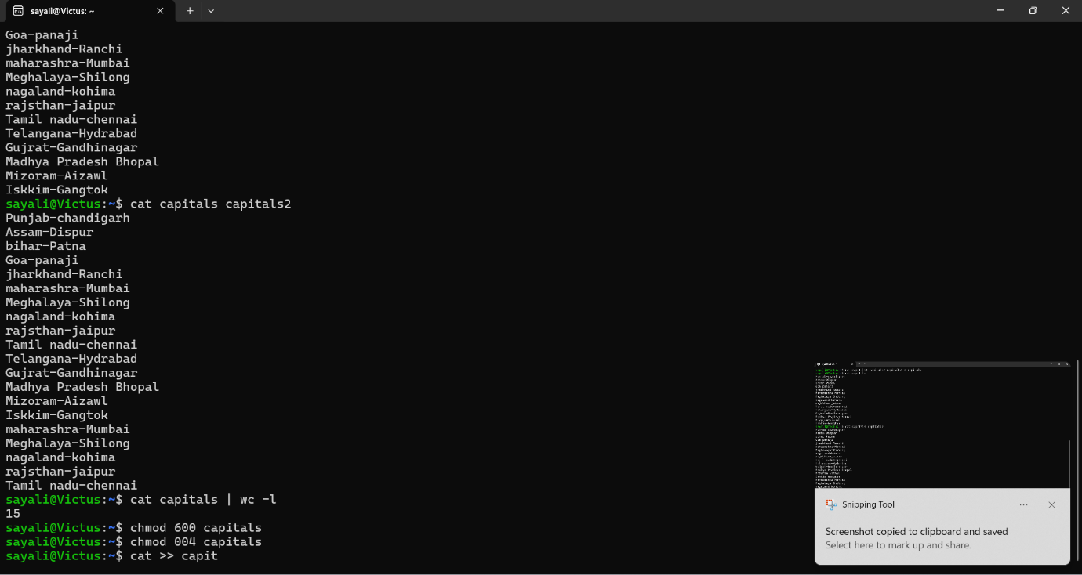
3. Give read and write permissions to all users for the file capitals.

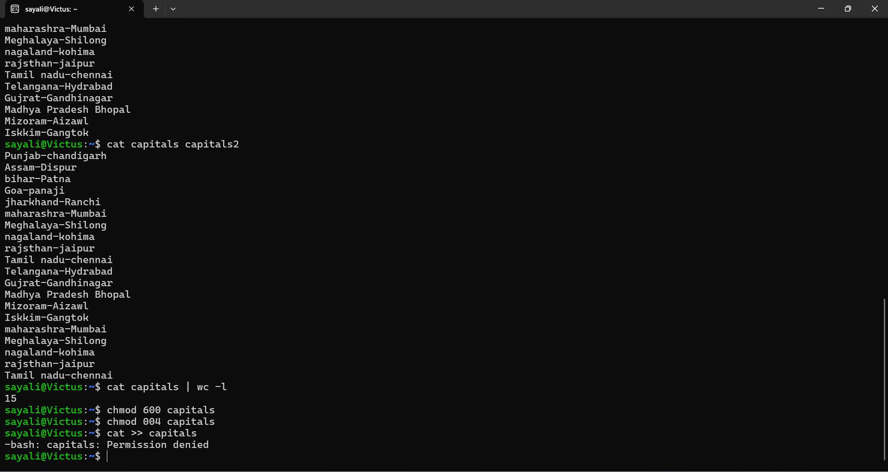

1. Give read permissions only to the owner of the file capitals. Open the file, make some changes and try to save it. What happens?
2. Create an alias to concatenate the 3 files capitals1, capitals2, capitals3 and redirect the output to a file named capitals. Activate the alias and make it run.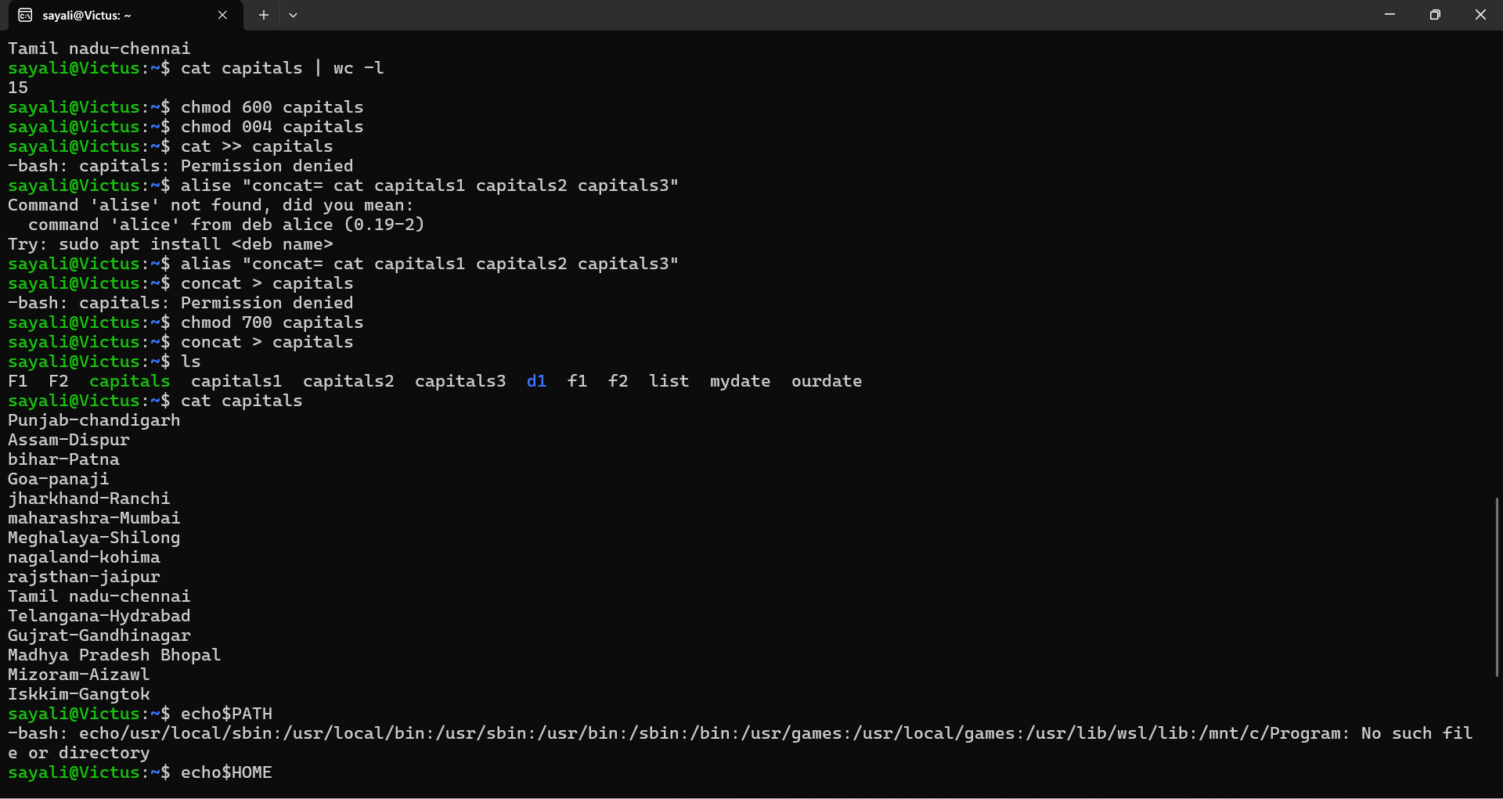
3. What are the environment variables PATH, HOME and TERM set to on your terminal?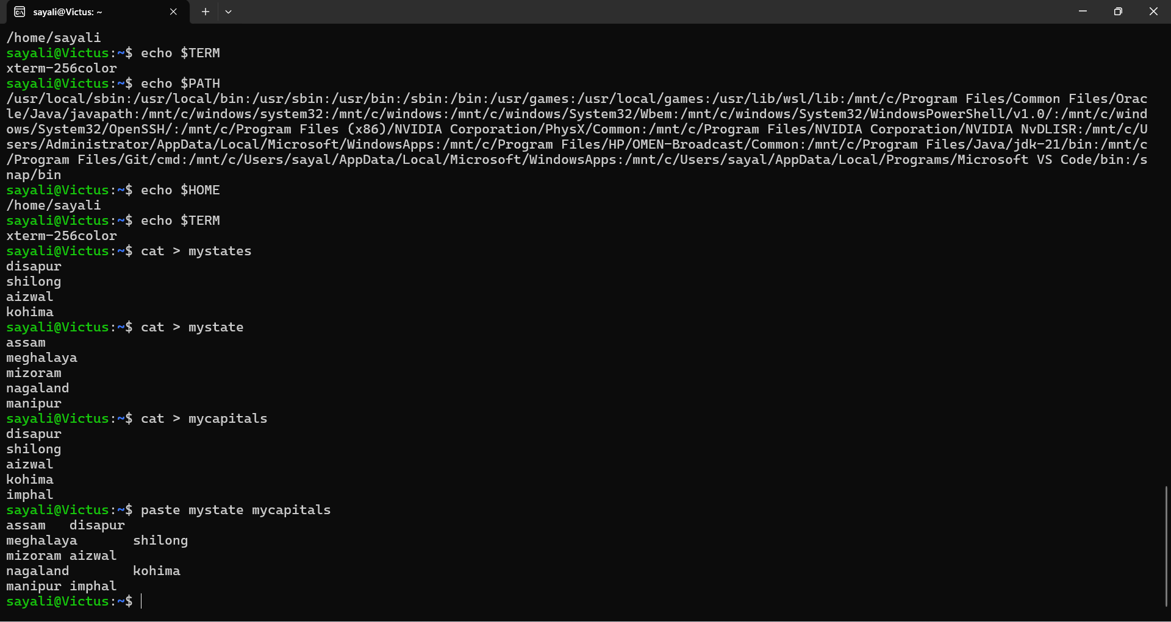
4. List 5 states in north east India in a file name *mystate.* List their corresponding capitals in a file *mycaptals*. Use the paste command to join the two files.